Corporation Tech
New Network Design & Plan - May 2022
Ryan Boucher
Corporation Tech
Table of Contents
Executive Summary 2
Part 1 – Network Design 3
Part 2 – Firewall Selection and Placement 4
Firewall Implementation 4
DMZ Implementation 6
Alternative User-Authentication 8
Part 3 – Remote Access and VPNs 8
IPSEC VPN’S 8
SSL/TLS VPN 9
Alternative forms of remote access 9
Different software’s and pricing for remote access and IPSEC VPN’S 10
Part 4 – Conclusions and Outcomes 10
Scenario 10
Tasks 11
Self-Assessment Checklist for Final Report 11
References 12

Executive Summary

Corporation Tech’s network is safe but could use tweaking to make it more secure. For some of my recommendations seen below I discussed the implementation of a DMZ which will separate our network keeping our PII and data behind a firewall separate from the outside internet. For the DMZ I also recommend upgrading the firewalls that are currently in place to Next generation firewalls which will increase security as these next generation firewalls contain tools and features to secure our network even more. I also recommend that IPV4 be upgraded to IPV6 as well because not only will it increase security among our organization, but it will also make routing among our network more efficient as well. I recommend as well that we start using multi- factor authentication as well to also secure our network requiring users to verify their identity in multiple ways before gaining access to our network and valuable information. Another recommendation I believe would be valuable to our organization is the implementation of an IPSEC VPN as it would secure our corporation more for users who work remotely. I also have detailed below some alternative forms of remote access so that employees who need access to certain areas of the network remotely can get that access. Detailed below is a comprehensive network diagram showing each change to our network and how it will improve with each upgrade. To conclude Corporation Tech’s network could use a security overhaul before it is deemed secure. Keeping user and employee information secure should be the top priority so hopefully this diagram and network assessment will be beneficial in the upgrades towards a more secure network for corporation tech.

Part 1 – Network Design
Diagram 1:
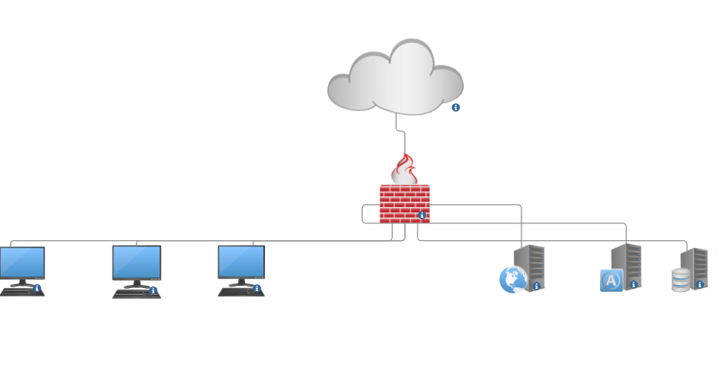

Shown above is the current network topology of Corporation Tech. As shown there isn’t much protection among the network as we are only using a singular border firewall. I believe we could prevent future attacks by implementing DMZ’s and firewalls among the networks. A DMZ would be most beneficial between our web server and the rest of the network because if hosts connect to the web server and that’s infected users could spread malware and other viruses amongst the networks. Implementing a firewall between host machines and database servers and application servers will exponentially increase security not only against outside threat actors (hackers) but also from workers that may have malicious intent. A firewall in these areas will prevent potential data theft or breaches. Another issue within our network is that all databases and machines are connected with no protection amongst them. It would be best to separate users and databases into work groups that will be classified amongst job positions. For example, employees who deal with software development shouldn’t have access to databases with customer payment information. We also need to implement a steady stream of communication that will be available 24/7 and for that situation I recommend we implement a communications server, and its sole purpose would be to enable communication amongst employees and customers. This communications server would allow users to send messages, voice calls, and video calls 24/7. A key aspect of our network will also be the upgrade of IPV4 to IPV6. The upgrade to IPV6 will benefit our company in many different aspects ranging from security to the efficiency of routing traffic. IPV6 will need to be implemented at some point in the future so I believe that implementation now before adding more machines or databases would be the most beneficial. IPV6 will benefit Corporation tech because it allows for more efficient routing, meaning that it will essentially be faster than the current systems we are operating on. This upgrade will also allow for us to enable more security measures in turn protecting more of our data and customers information.

Part 2 – Firewall Selection and Placement

Firewall Implementation
The current firewall at Corporation Tech is outdated and could be updated to increase security. With the selection of a new firewall this will increase security for the infrastructure of Corporation Tech. With the implementation of newer and potentially next-generation firewalls, this would increase the security of our company exponentially. Next generation firewalls contain tools and other features that increase security and mitigation of threats. Next- generation firewalls may be a bit more expensive but with the tools and capabilities they have to stop potential threats they are well worth the cost. Below I have listed several Next generation firewalls that could be implemented into the network.
Palo Alto (PA 410)- The Palo Alto 410 is a relatively price efficient NGFW that is priced around $825. This firewall has multiple different security features including features that can manage and detect threats and problems throughout the seven layers of a network. The Palo Alto 410 is the lowest tier of the Palo Alto 400 series, but I believe it is a solid pick for our company. The Palo Alto 410 is meant for smaller corporations and is built for mainly 25-50 users. This firewall hosts 13,000 new sessions per second and can host 64,000 at one time. I believe this Firewall would be a good pick and with the price it wouldn’t be unreasonable to purchase multiple to place within the network.
CISCO Firepower 1120- The CISCO firepower 1120 is the second to last tier of the Firepower 1000 series. This firewall is priced at $2100 and can host up to 1500 VPN peers and has an IPS throughput of 2.6gb/per second. With the increased number of users that are allowed this will also reduce latency that the PA-410 will have since the number of users are close to the maximum for the PA-410. This firewall also comes with CISCO device manager which allows for easier local management on devices connected to the network. This firewall also allows for easier URL classification with over 80 categories to place URL’s in for easier blocking and permissions. The CISCO Firepower 1120 is a bit pricier than the PA 410, but it also allows for more users and hosts while also having multiple different features.
pfsense+- pfsense is a free software based firewall but I believe if we decided to use pfsense the best route would be to pay for pfsense plus which is much cheaper than the other options listed above but the features are not as advanced. With pfsense plus the features you will get are Anti-spoofing and IP filtering with a few other security features. The pfsense+ subscription will cost about $129 a month which is a fairly good price, but the options are limited and minimal compared to having a physical firewall. The best way to have pfsense+ would also to implement it onto a physical firewall such as the Netgate 1100 pfsense+ security gateway. Pfsense is a very strong next-gen firewall, but I don’t believe it has the best features or specifications to fully protect our network.
The firewall I chose to implement, and use is the Cisco Firepower 1120 because it has the best protection and security features to protect our network. It is the most expensive option, but it has more user capabilities and other features to protect the network. I think the best place to implement this firewall would be between the internet and the workstations. With the implementation of the firewall, we can view traffic coming in and out of the network. With our firewall being placed here we can also block and restrict user access to websites that may be inappropriate or malicious for our network. I believe it would also be integral to put a firewall outside of our servers as well to protect and restrict access to information that is personably identifiable information.

DMZ Implementation
For increased protection of the network and personal data a DMZ would be important to implement as it would be an extra layer of security compared to the initial external firewall. A DMZ is known as a Demilitarized zone which basically is used to separate important aspects of the network (Ex. Production databases) from untrusted and unsafe sources such as the internet. The DMZ will protect our applications database and database servers. The DMZ Is integral for our network because it will separate aspects of our network from potentially dangerous areas such as the internet. This will add an extra layer of security because users who need to log into our network will have to pass through an extra firewall to gain access to important data/information. The purpose of placing these assets inside a DMZ is to restrict access to important information and processes that are integral in the functioning of Corporation Tech. The reason I’ve decided not to place all our databases and web server behind this DMZ is that it will cause latency and make access for users more difficult and would lead to a host of new problems. With too many databases and services behind a DMZ it would slow down our network and cause accessibility issues to integral parts of our infrastructure. How we would implement this DMZ is we would have our initial firewall blocking the internet and our second firewall segmenting our network separating our workstations, database servers, and applications servers. Below is a diagram of how our network should look if the DMZ is implemented successfully.

Diagram 2:
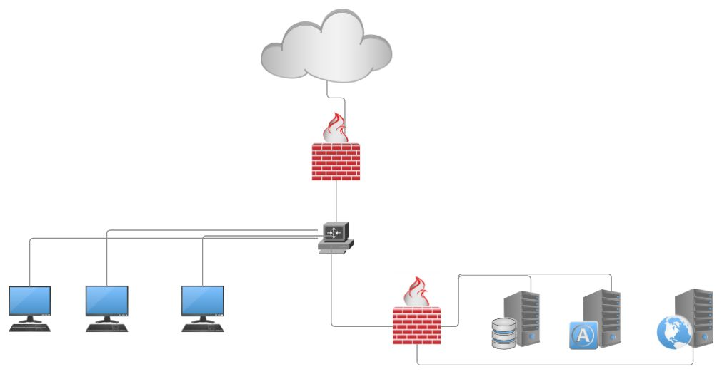

Alternative User-Authentication
As an added layer of security for our network we will be adding multi-factor authentication. To gain access to information or portions of our network users will need to input a code sent via SMS to a Corporation Tech issued Cell phone. The next form of authentication is users will need to input their respective password that is 16 characters long with two numbers and two special characters. For the final form of authentication users will be sent a token that will allow them access to the important aspects of the network. With the added layers of security this will help mitigate potential risks and many forms of hacking. With this added layer of protection, we will also be able to monitor who and what accounts have been able to access these portions of the network as well so this will also help with insider threats. The implementation of these multi factor authentication systems would not be difficult and would be relatively cost efficient since most of these systems are very inexpensive.

Part 3 – Remote Access and VPNs

IPSEC VPN’S
VPN’S are known as virtual private networks that will greatly increase the security of Corporation Techs network. There are 2 prevalent types of VPN’s we could use they are IPSEC VPN’s and SSL/TLS VPN’s. An IPsec VPN is mainly used to send data and Internet protocols across the internet with secure encryption making it difficult to access the information without a key. Authorized users of the IPsec VPN will have keys and will be able to decrypt and view information easily. What makes this protocol secure is that the source of the data is verified. What makes IPsec safe is the fact that information is encrypted as it leaves the network and decrypted once it reaches its destination so if the information is intercepted along the way it isn’t easy to decrypt. I believe that an IPSEC VPN would be more beneficial due to the encryption ability that is offered through an IPSEC VPN. This is a more effective way of transmitting data and protecting valuable information. Users with an IPSEC VPN will be able to view information remotely while also monitoring who views the files. IPSEC vpn’s are also notoriously much easier to manage compared to SSL/TLS Vpn’s.

SSL/TLS VPN

The second choice would be an SSL/TLS VPN. This VPN would be easier to implement but it isn’t as safe as an IPSEC VPN. An SSL/TLS VPN would basically be implemented into every host pc. Each host would be given credentials to log into a VPN portal which would only support HTTPS websites selected by our organization. While I prefer an IPSEC VPN a SSL/TLS would be beneficial as well since users would only be able to access secure websites and that would minimize the risk of malware and viruses coming through the browser. This form of VPN also requires fine tuning as well because some websites even with HTTPS may not be secure or may be too explicit for the work place.

Alternative forms of remote access
A few additional forms of remote access that I believe could be important would-be different forms of remote access software. This software would make it easy for employees to remote desktop into host machines and employ software patches and install programs when they are away from the office. This software would be important because it wouldn’t require employees to commute to the office and manually install patches and programs. A second form of remote access that Corporation Tech could benefit from would be virtual network computing or VNC. This protocol is like Remote desktop, but it allows the user on the host machine to still interact with their respective machine. A viewer would be installed on the machine that is meant to control the machine, while a VNC server would be installed on the machine that is meant to be controlled. The final form of remote access I would recommend is point-to-point tunneling protocol (PPTP), this uses a VPN that ensures encryption and safety so that the host can have their machine accessed remotely by an authorized user. This protocol uses encryption and different security techniques to ensure safe transmission and remote access.

Different software’s and pricing for remote access and IPSEC VPN’S
Listed below are a few different remote access software’s and IPsec VPN’s Corporation Tech could benefit from.

- Teamviewer is a reputable and respected remote-control software. This would cost about $230 a year but most of the corporations and most machines would be able to have this software installed.
- REALVNC is another alternative for remote virtual network control that is a well trusted and secure software. This is a bit pricier than the alternatives but I believe it would be the best choice. This costs about $500 a year but would be able to be installed amongst all machines.
- NordLayer is a prominent IPsec vpn and I believe that we could benefit from the use of their software. They offer multiple different plans but the premium which has the most features is priced at $14 per user per month. Which may be expensive, but it offers the most protection.

*Listed below is how our network should look with the implementation of our VPN
Diagram 3: 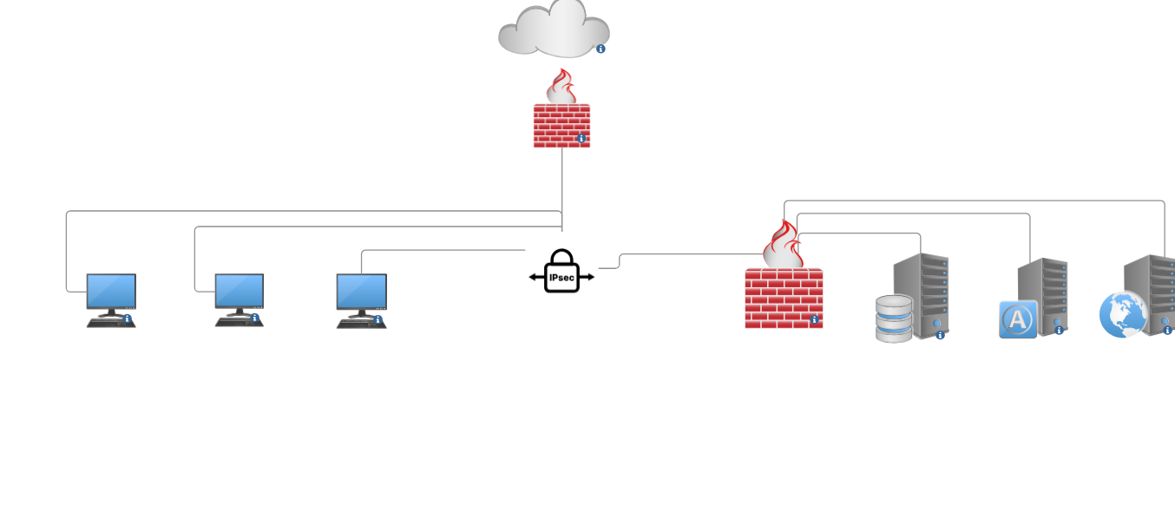

Part 4 – Conclusions and Outcomes

Diagram 4:

With the successful implementation of all of the security devices our network should look along the lines of this diagram.

References

1 https://app.smartdraw.com/editor.aspx?templateId=468ad179-ae88-4830-882a-25ea6df615bf&flags=128#depoId=54308543&credID=-59710957
3. https://www.devx.com/terms/communications-server/
4. https://aws.amazon.com/what-is/ipsec/
5. https://www.realvnc.com/en/blog/remote-access/

